Newton’s 2nd Law

PHYS 211L – H02

Tuesday 10:05am – 12:05pm

Abstract

In this lab, we investigated the relationship between the acceleration of objects that have different mass. We attached a string with mass on the end of it to a cart on a track, then recorded the time it took for the resulting tension force to pull the cart across a known distance. We used this information to calculate the acceleration of the cart, and then we compared it to the acceleration we calculated using Newton’s 2nd Law. By averaging our measurements, we determined that the acceleration of the cart based on Newton’s 2nd Law is (0.61865 ± 0.4) m/s/s, and the acceleration of the cart based on our recorded data is (0.578552 ± 0.3) m/s/s.

Introduction

[1] Isaac Newton was an English mathematician and physicist who significantly influenced the way that we view the laws of motion. He developed three laws that describe forces and how they work in the physical world. His second law, F = ma, is the one tested in this lab as we observe the relationship between force, mass, and acceleration.

In this experiment, we used the kinematic equation $d=v_{i}t+\frac{1}{2}at^{2}$ where $v_{i}$ = 0, $d$ is the distance between the two photogates, which we measured to be 0.5m, $t$ is the time it takes the cart to travel said distance, and $a$ is the acceleration of the cart during this motion. Simplifying for $a$, our equation then becomes $a={2d}/{t^{2}}$.

We also used Newton’s 2nd Law: $F=ma$ where $F$ is the net force acting on the system, $m$ is the mass of the system, and $a$ is the acceleration of the system. For this experiment, we know that the net force acting on the cart is equal to the tension force acting on the cart, thus $F_{T}=m_{c}a$. The net force acting on the rubber band is the weight of the rubber band minus the tension force acting on the rubber band, thus $m_{r}g-F_{T}= m_{r}a$. Substituting $m_{c}a$ into the second equation and solving for $a$ gives us $=$ $\frac{m_{r}g}{m_{c}+m_{r}}$. This is the second and final equation we used to calculate $a.$

For the experiment we set up a Pasco cart and track attached to a pulley system that used varying masses to exert a force on the cart in a horizontal direction. We recorded the acceleration and force exerted on the cart in order to find the mass of the cart using the equations derived in Newton's second law.

Procedure

In this lab, we used the following materials: balance, Pasco cart and track, bubble level, 1.1-meters of string w/ rubber band, timer attached to 2 photogates, 5-10g and 1-5g masses, pulley, and a small plastic fence.

First, we used the balance and bubble level to make sure the track was level. Then, we attached the string to the cart and put the string over the pulley. We set up the two photogates 30cm and 80cm away from the pulley. The small plastic fence was placed on the cart, as were 4 of the 10g masses. The remaining 10g mass and the 5g mass were attached to the rubber band.

Here is a diagram of our setup:

Photogates

Cart

Pulley and String

Mass

Track

We placed the cart right before the photogate at 80cm away from the pulley and held it back just before the red light on the photogate turns on so that our initial velocity is zero. We then released the cart and recorded the time it took to pass through the two gates. We did this five times and took the average of those times before moving 10g from the cart to the rubber band, and then we repeated the process until there weren’t any 10g masses left on the cart.

Results/Analysis/Physics

|  |  |  |  |  |  |  |
| --- | --- | --- | --- | --- | --- | --- |
| Mass of cart + mass on cart (kg) | Mass attached to rubber band (kg) | Average Time (s) | Uncertainty for Average Time (s) | Acceleration using 2d/t2 (m/s2) | Acceleration using Newton’s 2nd Law (m/s2) | Percent Difference between Accelerations |
| 0.540 | 0.015 | 1.99828 | 0.15068 | 0.25043 | 0.26514 | 5.7% |
| 0.530 | 0.025 | 1.58102 | 0.02982 | 0.40006 | 0.44189 | 9.9% |
| 0.520 | 0.035 | 1.31712 | 0.02742 | 0.57643 | 0.61865 | 7.1% |
| 0.510 | 0.045 | 1.15608 | 0.01978 | 0.74821 | 0.79541 | 6.1% |
| 0.500 | 0.055 | 1.04392 | 0.01318 | 0.91763 | 0.97216 | 5.8% |

Mass of cart + mass on cart: 0.540kg Mass of cart + mass on cart: 0.530kg

|  |
| --- |
| Time (s) |
| 1.5816 |
| 1.5605 |
| 1.5512 |
| 1.6017 |
| 1.6101 |

Mass on rubber band: 0.015 Mass on rubber band: 0.025kg

|  |
| --- |
| Time (s) |
| 1.8476 |
| 2.1289 |
| 1.8530 |
| 2.0426 |
| 2.1193 |

Mass of cart + mass on cart: 0.520kg Mass of cart + mass on cart: 0.510kg

Mass on rubber band: 0.035kg Mass on rubber band: 0.045kg

|  |
| --- |
| Time (s) |
| 1.3260 |
| 1.2897 |
| 1.3299 |
| 1.3299 |
| 1.3101 |

|  |
| --- |
| Time (s) |
| 1.1363 |
| 1.1731 |
| 1.1448 |
| 1.1566 |
| 1.1696 |

Mass of cart + mass on cart: 0.500kg

Mass on rubber band: 0.055kg

|  |
| --- |
| Time (s) |
| 1.0349 |
| 1.0571 |
| 1.0508 |
| 1.0442 |
| 1.0326 |

Calculated and Theoretical Acceleration (m/s/s) vs. Tension Force Pulling the Cart (N)

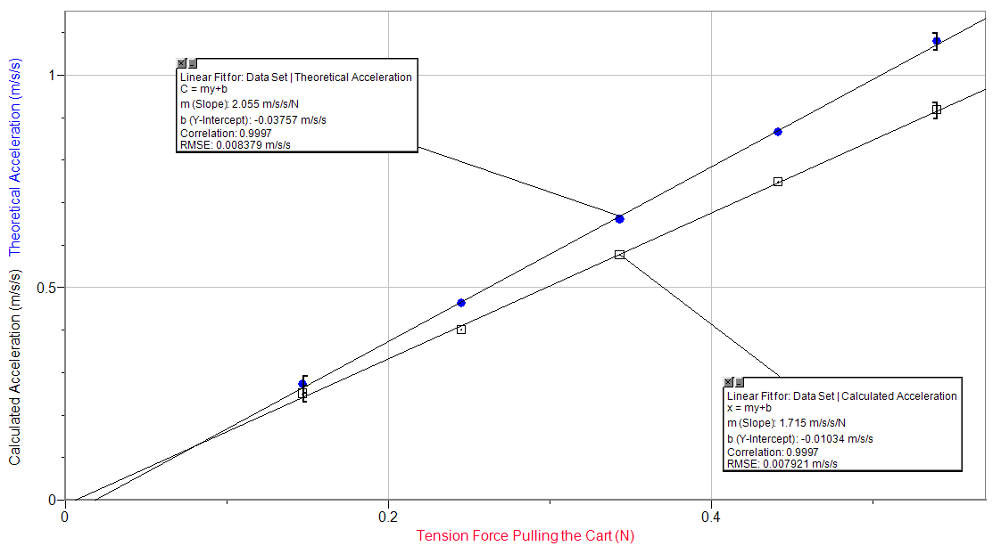

Free Body Diagram for the Cart while in Motion

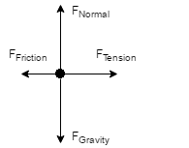

Free Body Diagram for the Rubber Band while in Motion

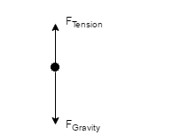

Conclusion

[What was learned] From this lab we experimented with the relationship between force, mass, and acceleration. We learned that as force is increased on a system and as the mass of the system decreases, the acceleration of the mass increases. Our data shows that the relationship between mass, acceleration, and force on the mass correlates with the findings of Newton in that force equals mass times acceleration. [Uncertainties] The primary uncertainty in our experiment system is the force of friction. As it is nearly impossible to create an ideal scenario, outside forces will almost always be present. In this situation, friction was present between the cart and the track as well as the string and the pulley. Both of these factors influence the net force acting on the cart, thus skewing the total acceleration of the cart. In addition to friction, it is impossible to place the cart at the exact position before the photogate to get the initial velocity to equal zero. While we were able to reduce this factor for the majority of the experiment, it is still present.

[Universal Question 1] Our collected data was fairly accurate to the expected results, our highest error being a 9.9% difference and the lowest being 5.7%. On average the percent error was 6.92%. This type of discrepancy is to be expected in a non-ideal scenario such as ours due to the uncertainties previously discussed. [Universal Question 2] The idea of Newton's second law is present in many aspects of everyday life. One specific instance would be a work attempting to push a box along the floor. The worker applies a certain force on the box measured by Newtons. The box, with mass m, will have an acceleration equal to the force divided by the mass. Another instance of this idea is present when you drive a car. The car is propelled by a force created by the engine and, depending on the mass, will experience an acceleration that is equal to the force in newtons divided by the mass in kilograms.

Lab Questions

2. The predictions of Newton’s 2nd Law do agree with our results because the percent difference was always less than 10%.

3. The slope of each best fit line on our graph is the reciprocal of the mass of the system. We measured the mass of the system to be 0.555kg, and the mass values of the system according to the graph are 0.61237kg and 0.48662kg.

4. There is friction between the track and the cart, and because of this friction not be accounted for in our calculations using Newton’s 2nd Law, those values for the acceleration are consistently larger than the values we calculated using our measurements for time and distance traveled.

References

1. Biography.com Editors. "Thin Skin Christians Alive and Upset." Thin Skin Christians Alive and Upset. A&E Television Networks, n.d. Web. 03 Oct. 2016.